SQL-HandsOn1

Alberta “Albi” Kovatcheva

## Part 1

Run the following queries:

### Query all columns for actors with the first name of "Cuba".

Query:

SELECT * FROM sakila.actor WHERE first_name = "Cuba";

Results (3):

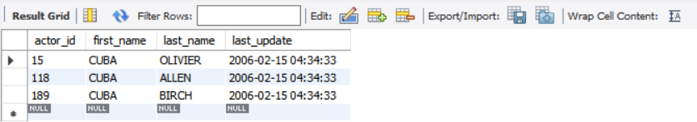

### Query the film title and film id that has an film_id greater than 5 and less than 20.

Query:

SELECT title, film_id FROM sakila.film WHERE film_id > 5 AND film_id < 20;

Results (14):

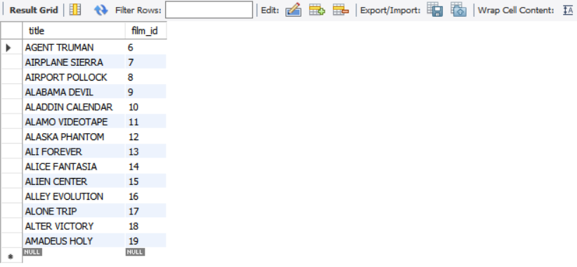

### Query the first and last name, and email of customers who have the last name "Rodriguez" or their last name begins with a "Mc".

Query:

SELECT first_name, last_name, email FROM sakila.customer WHERE last_name = "Rodriguez" OR last_name LIKE "Mc%";

Results (12):

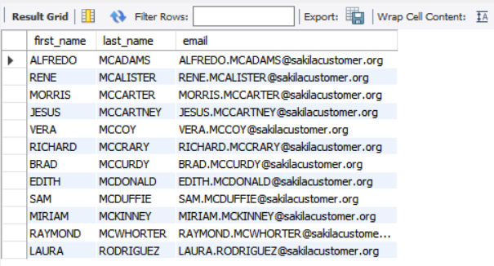

### Query all columns of the films with a title that begins with "a".

Query:

SELECT * FROM sakila.film WHERE title LIKE 'a%';

Results (97):

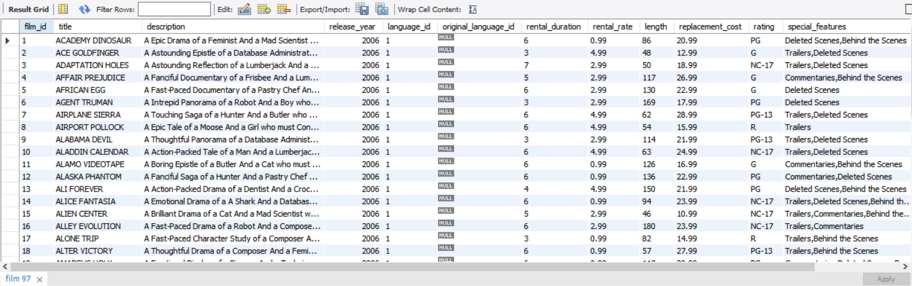

### Query all titles of films that are not in the language of English or Japanese.

Query:

SELECT title from sakila.film WHERE language_id NOT IN(SELECT language_id from sakila.language WHERE name = "English" OR name = "Japanese");

Results (0):



## Part 2

Below is a real-life scenario. Please read this scenario and run the appropriate queries needed.

You were just hired at a company as a data analyst, and your company needs some information from the database.

1. They would like to see all payments that had a rental amount is over .99 cents. However, they only want to see the rental id and payment date that is attached to that payment.

Query:

SELECT rental_id, payment_date FROM sakila.payment WHERE amount > 0.99;

Results (98):

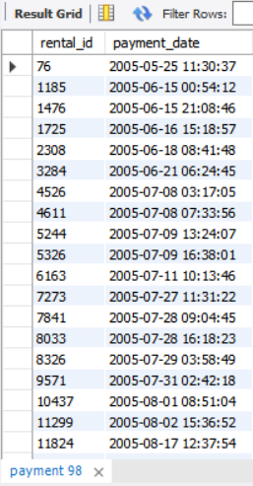

1. Once you have finished that, they would like to see the staff id and customer id from the payments that have an amount over .99 cents.

Query:

SELECT staff_id, customer_id FROM sakila.payment WHERE amount > 0.99;

Results(99):

